**Early Prediction For Chronic Kidney Disease Detection: A Progressive Approach To Health** **Management**

* **Project Description:**

Chronic Kidney Disease(CKD) is a major medical problem and can be cured if treated in the early stages. Usually people are not aware that medical tests we take for different purposes could contain valuable information concerning kidney disease. The information says that it helps us to measure the severity of the problem, the predicted survival of the patient after the illness, the pattern of the disease and work for curing the disease.

In todays world as we know most of the people are facing so many disease and as this can be cured if we treat people in early stages this project can use a pretrained model to predict the Chronic Kidney Disease which can help in treatment of peoples who are suffer from this disease.

* **Technical Architecture:**

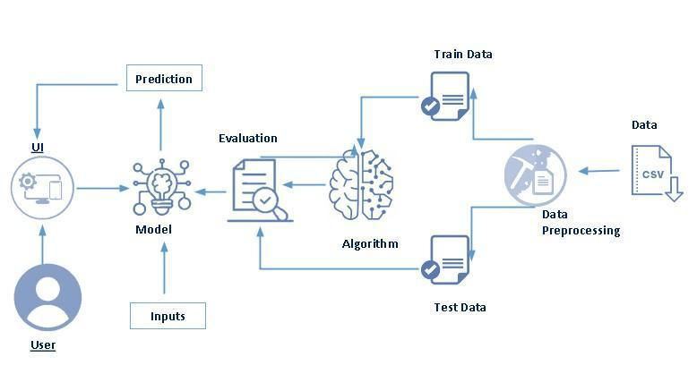

* **Project Flow:**
* User interacts with the UI to enter the input.
* Entered input is analysed by the model which is integrated.
* Once model analyses the input the prediction is showcased on the UI
* **Define Problem / Problem Understanding**
* **Specify The Business Problem**

Chronic Kidney Disease (CKD) is a major medical problem and can be cured if treated in the early stages.

* **Business Requirements**

The business requirements for a machine learning model to predict chronic kidney disease include the ability to accurately predict the ckd based on given information, Minimise the number of false positives and false negatives.

* **Literature Survey**

Chronic Kidney Disease (CKD) is a significant public health issue, affecting an estimated 14% of the global population. There have been numerous studies in recent years aimed at developing accurate and efficient methods for predicting CKD progression.

* **Social Or Business Impact**

On a social level, early detection of CKD can lead to improved patient outcomes and quality of life. This can help prevent the need for dialysis or kidney transplanation, which can be costly and life-altering for patients.

* **Data Collection & Preparation**
* **Importing The Libraries**

Import the necessary libraries as shown in the image. Here we have used visualisation style as fivethirtyeight.

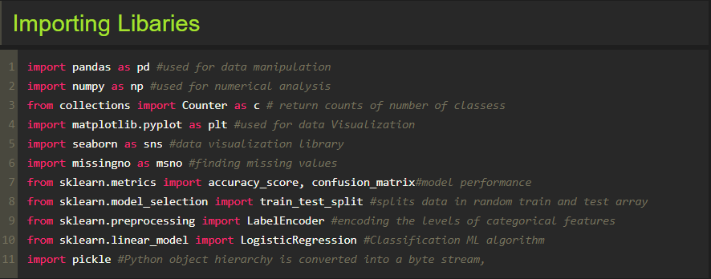

* **Rename The Columns**

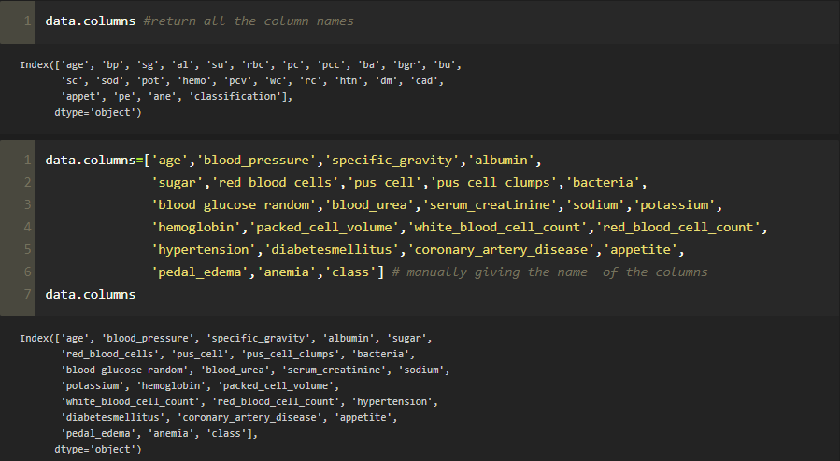

* **Label Encoding For Categorical Columns**

Typically, any structured dataset includes multiple columns with combination of numerical as well as categorical variables.

**Label Encoding** is a popular encodind technique for handing categorical variables.

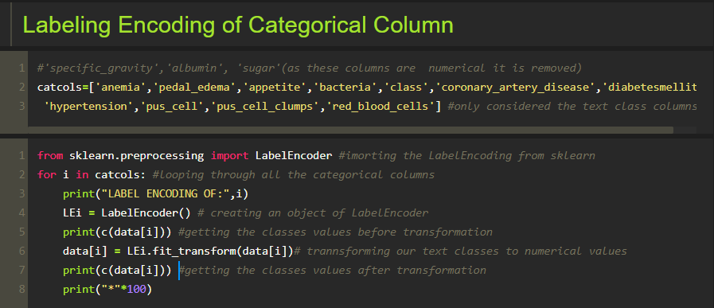

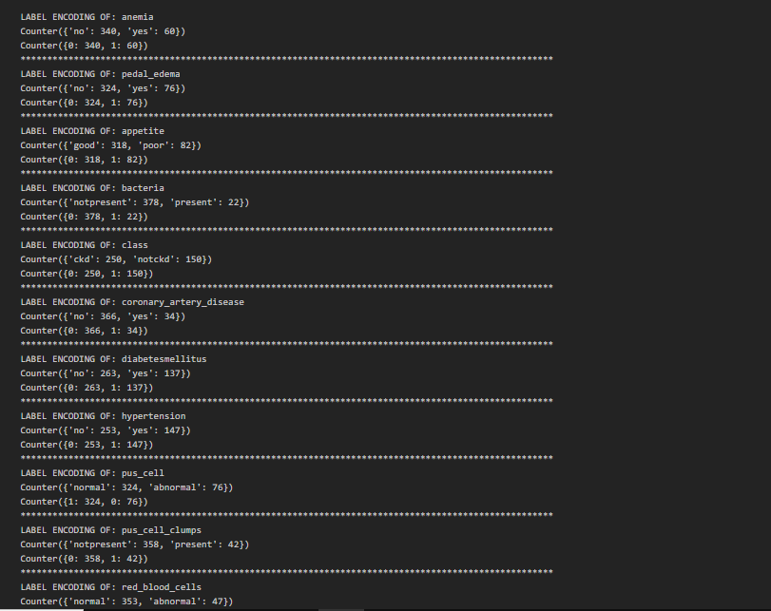

* **Exploratory Data Analysis**
* **Visual Analysis**

Visual analysis is the process of using visual representations, such as charts, plots and graphs, to explore and understand data. It is a way to quickly identify patterns, trends, and outliers in the data, which can help to gain insights and make informed decisions.

* **Univariate Analysis**

In simple words, univariate analysis is understanding the data with a single feature.

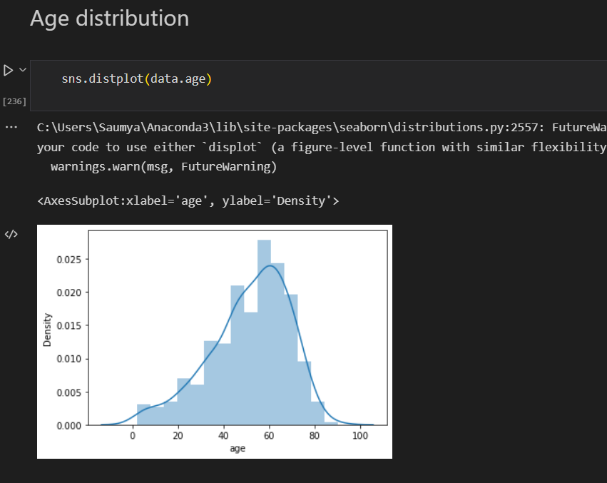

* **Bivariate Analysis**

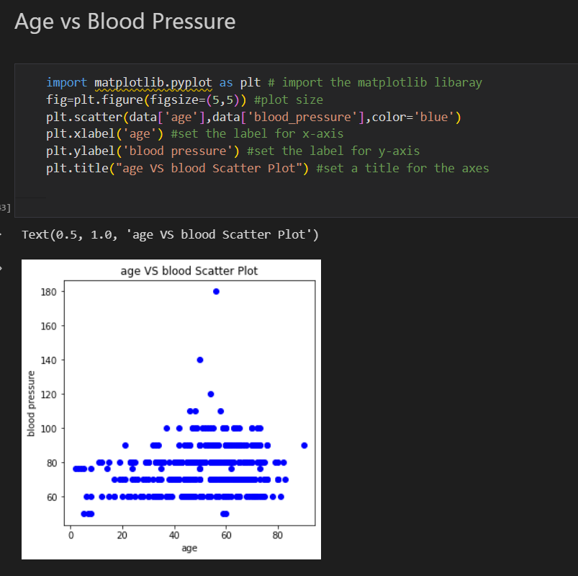

* **Model Building**
* **Training The Model In Multiple Algorithms**

Now our data is cleaned and it’s time to build the model. We can train our data on different algorithms.

* **ANN Model**

Building and training an Artificial Neural Network (ANN) using the keras library with TensorFlow as the backend. The ANN is initialised as an instance of the sequential class, which is a linear stack of layers.

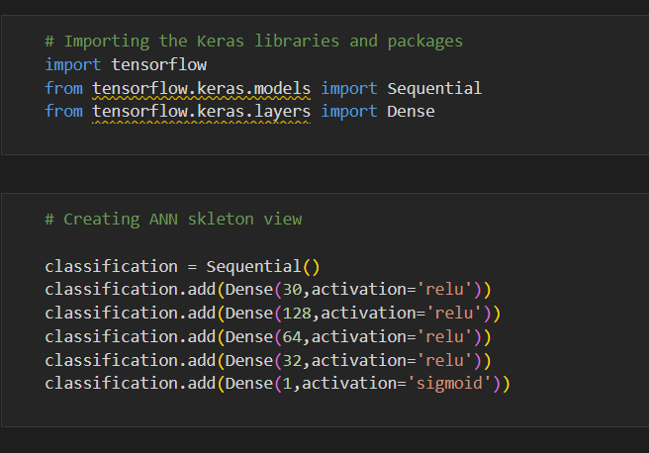

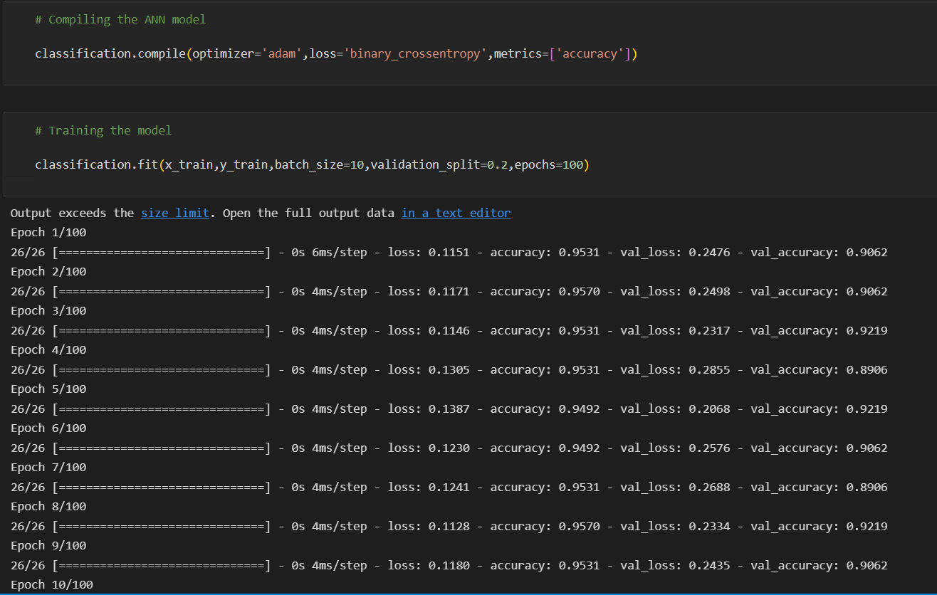

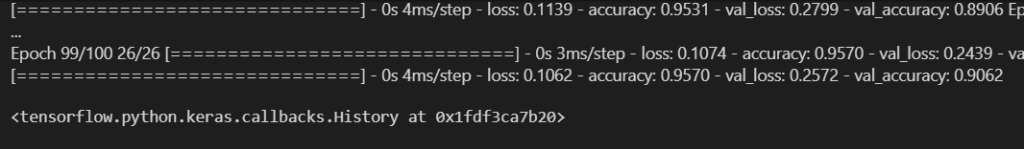

* **Random Forest Model**

A function named random forest is created and train and test data are passed as the parameters. Inside the function, Random Forest Classifier algorithm is initialised and training data is passed to the model with .fit() function.

* **Logistic Regression**

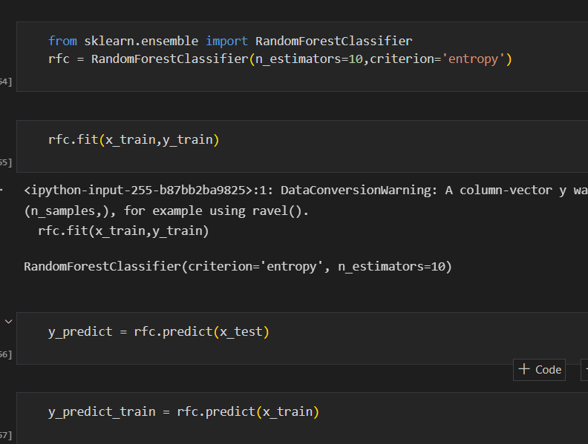

* **Performance Testing & Evaluate The Results**
* **Testing Model With Multiple Evaluation Metrics**

Multiple evaluation metrics means evaluating the model’s performance on a test set using different performance measures. This can provide a more comprehensive understanding of the model’s strengths and weaknesses.

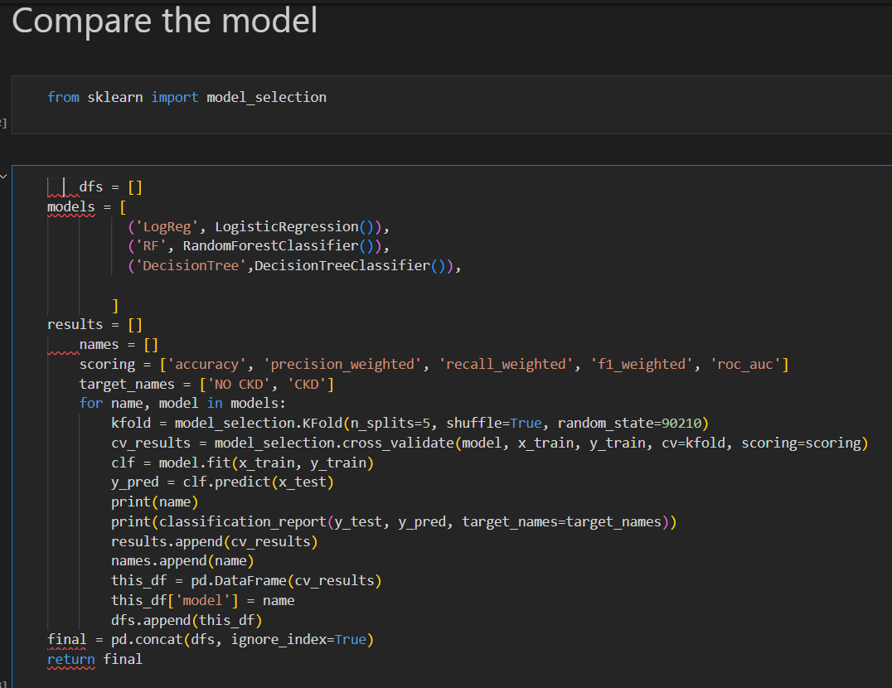

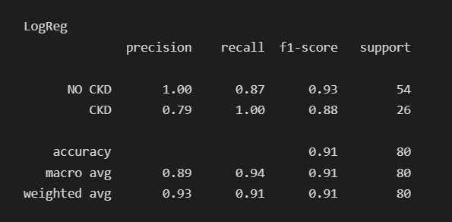

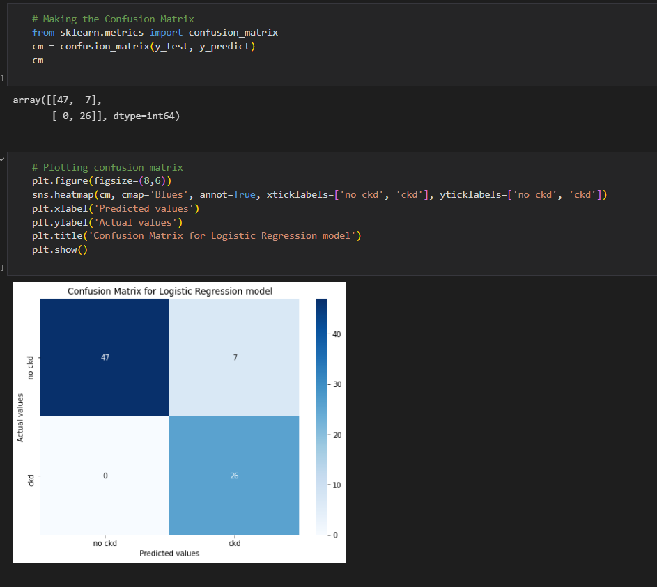

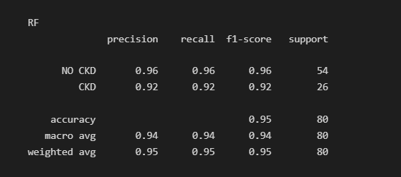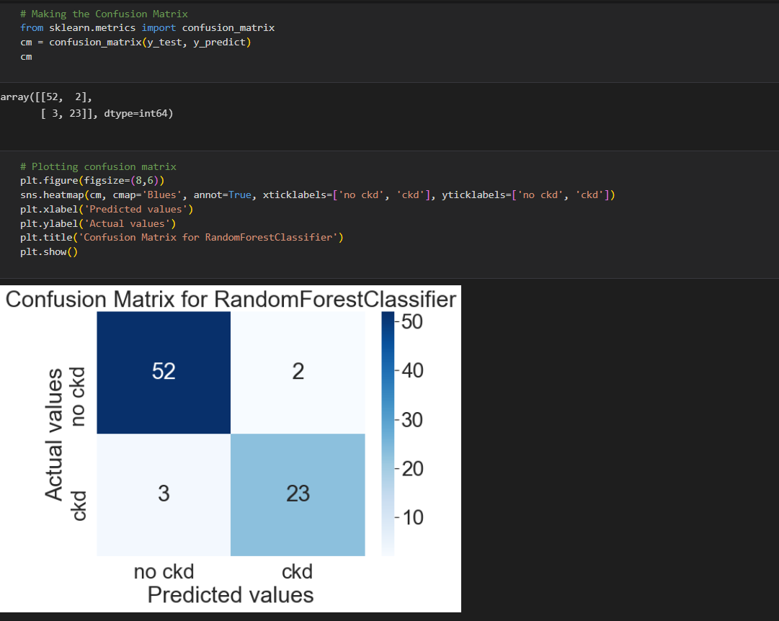

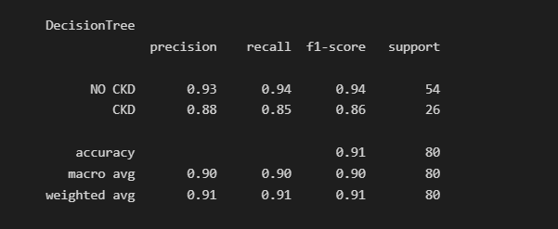

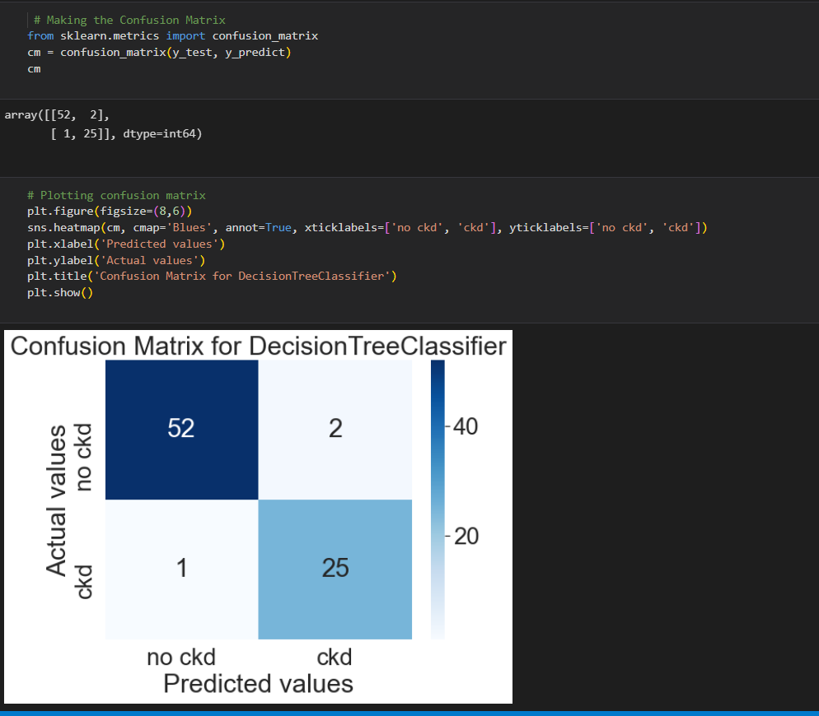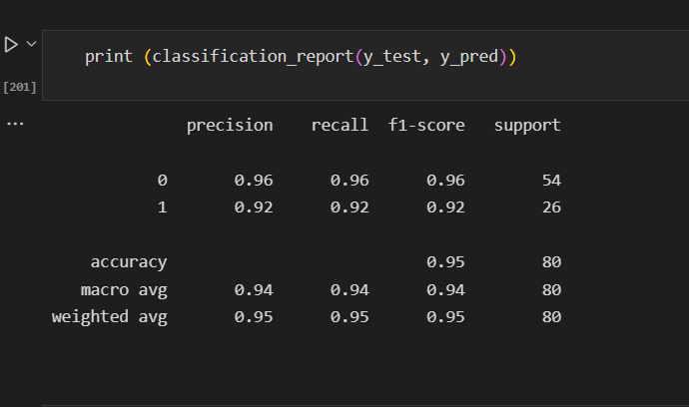

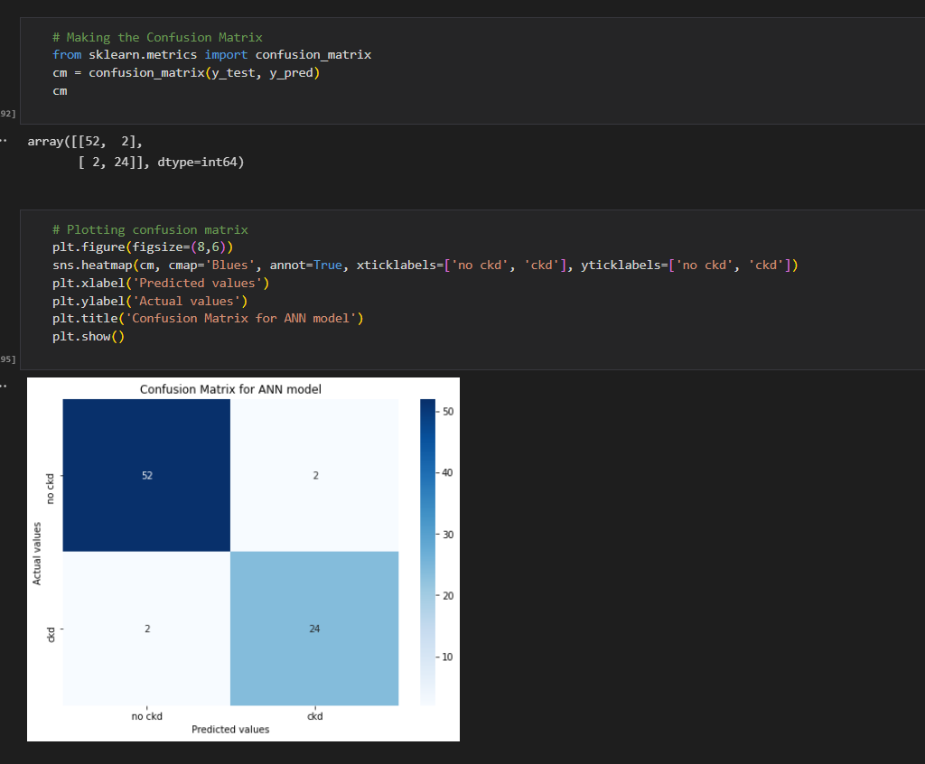

* **Evaluate The Results**

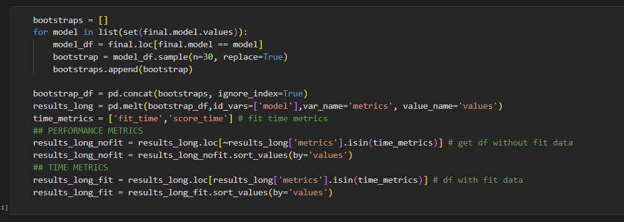

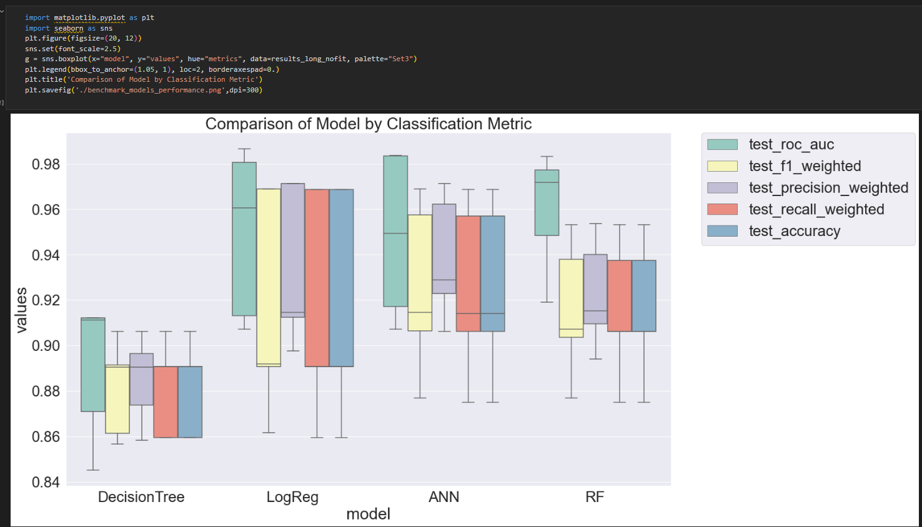

* **Model Deployment**
* **Save The Best Model**

Saving the best model after comparing its performance using different evaluation metrics means selecting the model with the highest performance and saving its weights and configuration. This can be useful in avoiding the need to retrain the model every time it is needed and to be able to use it in the future.

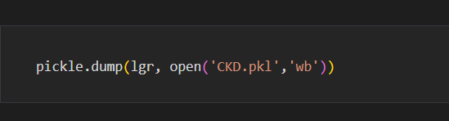

* **Integrate With Web Framework**

In this section, we will be building a web application that is integrated to the model we built. A UI is provided for the uses where he has to enter the values for prediction is showcased on the UI.

This is section has the following tasks

* Building HTML Pages
* Building server-side script
* Run the web applicatio
* **Building Html Pages**

For this project create four HTML files namely

* home.html
* index1.html
* indexnew.html
* Result.html

And save them in the templates folder

* **Run The Web Application**
* Open anaconda prompt from the start menu
* Navigate to the folder where your python script is.
* Now type “python app.py” command
* Navigate to the localhost where you can view your web page.
* Click on the predict button from the top left corner, enter the inputs, click on the submit button, and see the result/prediction on the **web.**

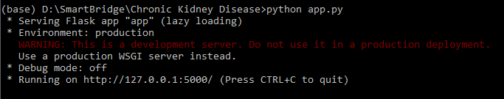

* **Project Demonstration & Documentation**
* **Record Explanation Video For Project End To End Solution**
* **Project Documentation-Step By Step Project Development Procedure**